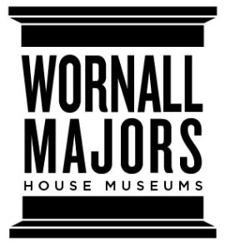
The Wornall/Majors House Museums
Position Description: Alexander Majors Barn Event Attendant

The John Wornall House Museum The Alexander Majors House & Barn
6115 Wornall Road 8201 Stateline Road
Kansas City, MO 64113 Kansas City, MO 64114

Position Summary
Event Attendants at the Alexander Majors Barn are responsible for opening and closing the event space, stocking restrooms with paper products, and generally overseeing the venue during events such as weddings, parties, and meetings. Events may also take place inside the Alexander Majors House Museum and the John Wornall House Museum. This is an independent contracting position; hours are not guaranteed and are subject to seasonal changes in rental volume. Event Attendants choose their shifts on a first-come, first-served basis and report directly to the Executive Director of the Wornall/Majors House Museums. Core hours are typically Fridays-Sundays, and typically involve evening shifts.
Duties & Responsibilities
- Perform the regular procedures to open and close the venue & prepare it for events.
- Stock with paper products & monitor the venue’s restrooms during events.
- Represent the Wornall/Majors House Museums professionally, courteously, and consistently during events.
- Be available to answer clients’ questions about the venue & to assist with matters related to the venue (i.e. doors, lights, directing vendors).
- Inform the Executive Director/appropriate Wornall/Majors staff of potential issues and/or violations of venue policies.
- Go through the venue check-out list with clients before they leave the premises.
- Assist in coordinating payment of security officers provided by KCPD (if needed).
- Event Attendants will track their own hours and report them monthly by the 25th of the month.
- Ensure the venue is properly secured at the end of every event.
Other Responsibilities:
- Assist in maintaining the overall inviting and presentable environment of the facilities and grounds, as needed.
- Enforce critical policies of the Alexander Majors Barn and Wornall/Majors House Museums (i.e. restrictions on smoking/open flame, alcohol policy, etc.)
- Other duties as assigned.
Qualifications
- Strong written & verbal communications skills
- Excellent interpersonal manners and professional appearance
- Can-do, problem-solving attitude
- Experience in hospitality, retail, or service industry a plus.
Compensation: Pay rate $10.00 per hour.
To apply send resume to:
Kerrie Nichols, Executive Director
rentals@wornallmajors.org

